 |  |  |  |  | Building Control Service  Council Offices, Holt Road, Cromer NR27 9EN  Tel: (01263) 513811 Fax: 01263 516348  Email: building.control@north-norfolk.gov.uk  This form is to be filled in by the owner or agent. Please type or use block letters.  If the form is unfamiliar, please read the notes on the next page or consult the office above |  |  |  | FULL PLANS SUBMISSION  The Building Act 1984  The Building Regulations 2010
 |  |  |  |  |  |  |  |  | Building Regulations Plan No:
 | 1 |  | Applicants details
 | 1 |  | Full Name:
 | 1 |  | Address:
 | 1 |  |  |  |  |  |  | Postcode: |  | Tel:
 | 2 |  | Agents details
 | 2 |  | Name:
 | 2 |  | Address:
 | 2 |  |  |  |  |  |  | Postcode: |  | Tel:
 | 3 |  | Location of building to which work relates
 | 3 |  | Address:
 | 3 |  |  |  |  |  |  | Postcode: |  | Tel:
 | 4 |  | Proposed Work
 | 4 |  | Description:
 | 5 |  | Planning
 | 5 |  | If the work has a planning consent, or there is a planning application in progress, please give the reference number
 | 6 |  | Use of building
 | 6 |  | 1. If new or extension, please state proposed use
 | 6 |  | 2. If existing building, state present use
 | 6 |  | 3. The premises /IS NOT (PLEASE SELECT) intended to be put to a use which is a designated use for the purposes of the Fire Precautions Act 1971 and/or is covered by the Fire \Precautions (Workplace) Regulations 1997
 | 7 |  | Charges (see guidance note on charges for information)
 | 7 |  | Please state Table used (A-E) Category used (1-7)
 | 7 |  | 1) New Dwellings - No of Dwellings No of House Types
 | 7 |  | 2) Extensions & New Buildings m²
 | 7 |  | 3) Estimated Construction Costs
 | 7 |  | 4) Estimated Construction Period months
 | 7 |  | Plan Charge £ VAT at 20% Total £
 | 8 |  | For Office Use Only
 | 8 |  | Date Deposited: |  |  | Table: Category: |  |  |  |  | Rec No:
 | 8 |  | Plan Charge Received: |  |  | Card / Cheque / Other |  |  |  |  | Estimated Cost:
 | 8 |  | Inspection Charge: |  |  | Table: Category:
 | }  9 |  | Statement
 | }  9 |  | This notice is given in relation to the building work as described, and submitted in accordance with Regulation 12(2)(b) and is accompanied by the appropriate charge. I understand that a further charge will be payable following the first inspection by the Local Authority
 | }  9 |  | I agree to the Council exercising the option to approve the application with conditions if considered appropriate  I agree to an extension of time for the consideration of this application to take place prior to formal decision being issued, such extension to terminate two months from the date of deposit of plans  I require that you issue a completion certificate upon satisfactory completion of the works (mandatory where a designated use is involved) |  |  |  |  |  |  |  |  |  | Section 16  Building Act 1984  Delete if not required
 | }  9 |  |  | Name: |  |  | Signature: |  |  |  |  | Date:
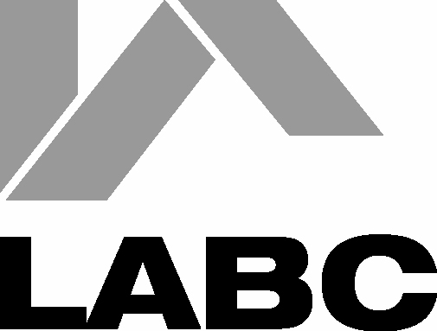

NOTES

1. | This notice should be completed and submitted with plans and particulars, in duplicate, in accordance with the provisions of Building Regulation 14
2. | Subject to certain exceptions a Full Plans Submission attracts charges payable by the person by whom or on whose behalf the work is to be carried out. Charges are payable in two stages. The first charge must accompany the deposit of plans and the second charge is payable after the first site inspection of work in progress. This second charge is a single payment in respect of each individual building, to cover all site visits and consultations which may be necessary until the work is satisfactorily completed. The appropriate charge is dependant upon the type of work proposed. Charge scales and methods of calculation are set out in the Guidance Note on Charges which is available on request.
3. | Subject to certain provisions of the Public Health Act 1936 owners and occupiers of premises are entitled to have their foul and surface water drains and sewers connected to the public sewers, where available. Persons wishing to make such connections must give not less than 21 days notice to the relevant Authority.
4. | Section 16 of the Building Act 1984 provides for the passing of plans subject to conditions. The conditions may specify modifications to the deposited plans and/or that further plans shall be deposited.
5. | These notes are for general guidance only; particulars regarding the deposit of plans are contained in Regulation 14 of the Building Regulations 2010 and, in respect of charges, in The Building (Local Authority Charges) Regulations 2010.
6. | Persons proposing to carry out building work or to make a material change of use of a building are reminded that permission may be required under the Town and Country Planning Act.
7. | Further information and advice concerning Building Control and Planning matters may be obtained from your Local Authority.
8. | Designated uses are use as a Hotel or Boarding House, use as a Factory, use as an Office, use as a Shop or Railway Premises

North Norfolk District Council is registered under the Data Protection Act 1998 for the purpose of processing personal data in the performance of its legitimate business. Any information held by the Council will be processed in compliance with the principles set our in the Act.

The Council must protect the public funds it holds so any information you provide on this form may be used by the Council to prevent and/or detect fraud. The information may be shared, for the same purpose, with other organisations which handle public funds.

Further information relating to the Data Protection Act 1998 can be sent to you on request.

If you have any concerns about the processing of your personal data by the Council you may contact the Data Protection Officer at North Norfolk District Council or the Office of the Information Commissioner at Wycliffe House, Water Lane, Wilmslow, Cheshire, SK9 5AF.

