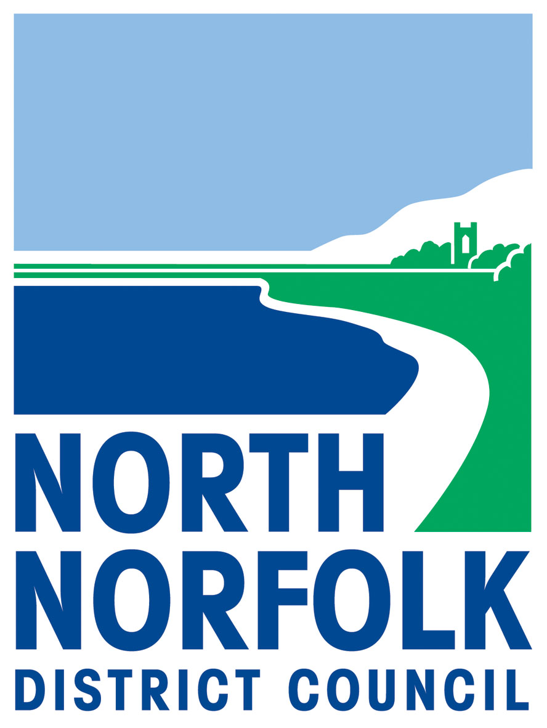

Beach Party/ Barbeque Application Form

The Byelaws reproduced overleaf affect this application

Application to hold a beach party / barbecue on the designated area of what beach?
Organiser Name
Club / Organisation (if appropriate)
Contact Address

Contact Tel no / email
Date of party / bbq
Anticipated start and end time | Start End  (no later than 12.00 midnight)
Reason for event
Anticipated numbers of attendees (see below)

If the event is confirmed by the District Council the following
conditions will have to be adhered to:

- The event shall be held entirely at the organiser’s risk. The council will accept no liability in respect of any claim whatsoever that may arise in respect of any injury, loss or damage direct or indirect suffered by the organiser, the club or any individual attending the event.
- No glass or glass utensils shall be used at the event or taken to the beach.
- All rubbish and litter is to be cleared away from the beach directly after the event and taken away with you. If rubbish is left on the beach North Norfolk District Council will send in a clean-up team and you will be charged accordingly.
- Noise must be kept to a minimum.
- The event must finish at midnight.
- No more than 75 persons may participate in the event. In very special circumstances, the Council is prepared to consider applications from bona fide organisations to increase the limit.
- At least one responsible adult to be in attendance at all times.

This application must be received by Leisure Services at least seven days before the party takes place:

Leisure Services, North Norfolk District Council, Council Offices
PO Box 3, Holt Road, Cromer, Norfolk NR27 9EN or email:-
Leisureandlocality@north-norfolk.gov.uk

NNDC will notify the Police and Coastguards of the event.

Signature of Organiser : …………………………………………………………

Position : ………………………………………………………..

Date : …………………………………………………………

COPY
BYELAWS
BEACH PARTIES AND BARBECUES

Byelaws made by the North Norfolk District Council by virtue of the powers conferred on the Council by Section 82 of the Public Health Acts (Amendment) Act 1907.

- Where any part of the Seashore has by notices affixed in conspicuous positions on the Seashore been set apart by the Council for the holding or parties or barbecues no person shall hold any party or barbecue on any other part of the Seashore.

- A person shall not on any part of the Seashore so set apart by the Council for the holding of parties or barbecues organise any party or barbecue unless:

- he has given to the Chief Executive and Clerk of the Council seven days prior notice in writing or as soon as reasonably practicable after that time specifying the site, date, time and period of duration of the party or barbecue and
- he has not been notified in writing by the Chief Executive and Clerk of the Council that at the date and time specified in his notice the use of the site has been claimed by an earlier applicant.

- A person shall not on any part of the Seashore so set apart by the Council for the holding of parties and barbecues commence to hold a party or barbecue before the time or continue it for longer than the period of duration specified in the notice given under sub-paragraph (a) of Byelaw 2.

- This Byelaw shall not apply to any party or barbecue attended by 12 or less people.

- In proceedings against any person for an offence under Byelaw 2 or 3 above this shall be a defence for that person to prove that he had taken all reasonable precautions and exercised all due diligence to avoid the commission of the offence.

- Every person who shall offend against any of these Byelaws shall be liable on summary conviction to a fine not exceeding one hundred pounds (£100.00).

Made this twelfth day of

THE COMMON SEAL OF NORTH )
NORFOLK DISTRICT COUNCIL ) L.S.
was hereunto affixed in )
the presence of: )

Mr Simon Partridge Philip Burton
Chairman Chief Executive & Clerk

The foregoing Byelaws are hereby confirmed by the Secretary of State and shall come into operation one calendar month after the date on which the consent of the Department of Transport is given to the Byelaws.

Signed by authority of the Secretary of State
M E Head
An Assistant Under-Secretary of State
26 August 1986
Home Office
LONDON SW1

The Secretary of State for Transport hereby consents to the foregoing Byelaws.

J R Fells
(Signed by an Assistant Secretary of the Department of Transport)

11 September 1986 (Byelaws Beach Parties and Barbecues)

