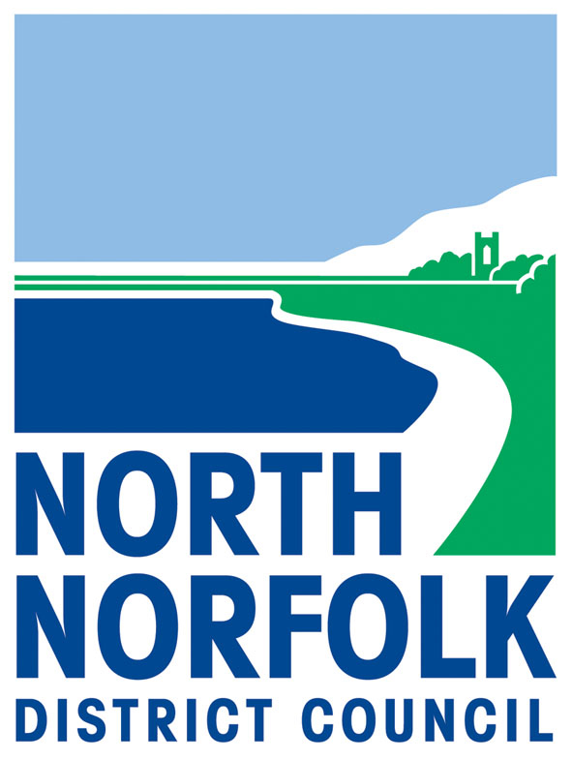
Local Government (Miscellaneous Provisions) Act 1976

Application for a Variation of
Hackney Carriage or Private Hire Vehicle

1 | Standard applicant profile section
1.1 | Full Name
1.2 | Full Postal Address
1.3 | Main contact telephone number
1.4 | Other telephone number
1.5 | Email address

Declare that I being the holder of Private Hire/Hackney Carriage Licence No (delete as appropriate)
Wish to vary this Licence, subject to the provisions of Part II of the Local Government (Miscellaneous Provisions) Act 1976, to use the motor vehicle detailed below.

Please complete all the questions on the form in BLOCK capitals and in black ink.
If you have nothing to record, please state "Not applicable" or "None".

2 | Reason for Variation
2.1 | Private Hire to Hackney Carriage
2.1 | Private Hire to Hackney Carriage | Yes |  | No
2.2 | Hackney Carriage to Private Hire
2.2 | Hackney Carriage to Private Hire | Yes |  | No
2.3 | Change of Registration Number
2.3 | Change of Registration Number | Yes |  | No
2.4 | Modification of vehicle  e.g colour change, seating.
2.4 | Modification of vehicle  e.g colour change, seating. | Yes |  | No
2.5 | Change of Operator
2.5 | Change of Operator | Yes |  | No

3 | Current Details of Vehicle
3.1 | Registration Number
3.2 | Make
3.3 | Model
3.4 | Expiry date of current Licence Plate

4 | New Registration Number of Vehicle
4.1 | Registration Number
4.2 | Date effective from

5 | Modification of Vehicle
5.1 | State modification(s) made
5.2 | Date effective from

6 | Operator Details
6.1 | Full name of Operator
6.2 | Name of Company
6.3 | Operator Licence Number
6.4 | Operator telephone number
6.5 | Operator email address

7 | Standard declaration and signature section
7.1 | I am the Proprietor of the vehicle to which this application applies. The following are the full names and addresses of every Proprietor or part Proprietor of the vehicle or every person concerned, either solely or in partnership with any other person in the keeping, employing or hiring of the vehicle.
7.2 | Full Name |  | Full Name
 | Address |  | Address
 | Nature of Association |  | Nature of Association
7.3 | I declare that the motor vehicle detailed in this application is owned by the applicant(s) and that to the best of my knowledge and belief, the above particulars are true in every respect. I have read the Licence Conditions and undertake in case of the Licence being granted, to observe and perform such Conditions.  I undertake to read and understand the Hackney Carriage and Private Hire Handbook and, in the event of a licence being granted, will observe and perform the requirements contained therein at all times.  This Authority is under duty to protect the public funds it administers, and to this end may use the information you have provided on this form for the prevention and detection of fraud. It may also share this information with other bodies responsible for auditing or administering public funds for these purposes.  Signature
7.5 | Print Name
7.6 | Date
7.7 | IT IS AN OFFENCE FOR ANY PERSON TO KNOWINGLY OR RECKLESSLY MAKE A FALSE STATEMENT OR TO OMIT ANY PARTICULAR MATERIAL IN GIVING INFORMATION IN THIS FORM. YOUR ATTENTION IS DRAWN TO SECTION 40 TOWN POLICE CLAUSES ACT 1847 AND SECTION 48(3) LOCAL GOVERNMENT (MISCELLANEOUS PROVISIONS) ACT 1976, WHICH ARE PRINTED ON THE LAST PAGE OF THE CONDITIONS

8 | Supporting Documentation Checklist
 | This form should be completed and returned to Licensing Section, North Norfolk District Council, Holt Road, Cromer, Norfolk NR27 9EN. Please ensure the following documents are enclosed with application. Non compliance will result in application being returned as invalid.
8.1 | Vehicle Registration Document (original) for new vehicle
8.2 | Insurance Document (Original)  (valid at time licence to commence covering appropriate vehicle use e.g public hire and/or private hire)
8.3 | Vehicle Inspection Report(s) if re-test required, submit initial test and any subsequent re-test reports)  Date of initial test Date of retest
8.4 | Appropriate Fee  (refer to Taxi Licensing Fee Sheet) | Basic Administration Fee
8.4 | Appropriate Fee  (refer to Taxi Licensing Fee Sheet) | Vehicle Inspection Test
8.4 | Appropriate Fee  (refer to Taxi Licensing Fee Sheet) | Vehicle Inspection Re-test
8.4 | Appropriate Fee  (refer to Taxi Licensing Fee Sheet) | Other Fees
8.5 | Return Current Plates – for changes to licence type and registration number

9 | Preferred Payment Methods
9.1 | Debit/Credit Card (via website/telephone/in council offices) | Payment codes:  1171 8252 604026 – Change from HC to PH or PH to HC  1171 8252 604032 - Change of vehicle registration number  1171 8252 604031 – Modification of vehicle /  Change of Operator details
9.2 | Cheque/postal order (via postal service/in council offices) | Payable to NNDC

10 | Service Statement
10.1 | We will process any applications within 7 working days on receipt of a valid and acceptable application.

