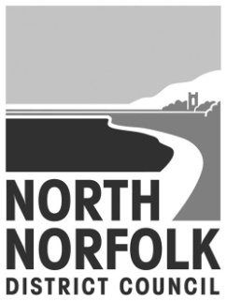
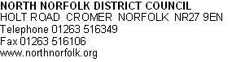

Our Ref:
Direct Dial: (01263) 516349
Direct Fax: (01263) 516106

LANDLORD NAME
LANDLORD PARTY ADDRESS

Dear Sir or Madam,

Housing Benefit Payments

Claimants that are subject to Local Housing Allowance are not as a general rule able to opt to have their benefit paid directly to their landlord. However there are some circumstances where the authority can consider making direct payments if it is deemed to be in the overriding interests of the claimant to do so.

In addition to this there are also safeguards in place with a view to protecting landlords and to stop claimants who cannot manage their rent payments from falling into arrears.

If you think that sending direct payments to a tenant will cause them, or you, serious problems, please complete this form and return it to us.

Yours sincerely,
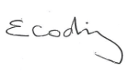
Elisabeth Codling
Benefits Manager
Tel (01263) 516349
Between: 8.30am – 5.00pm Monday, Tuesday, and Thursday
10.00am – 5.00pm Wednesday and 8.30am – 4.30pm Friday
Email: benefits@north-norfolk.gov.uk

Payment to Landlord Request Form
(For completion by the landlord or someone helping the tenant)

Your name: ...............................................................................................................
Your address: ...........................................................................................................
....................................................................................................................................................................................................................................................................

Your relationship to the tenant, e.g. landlord, relative, friend, social worker, care worker,etc.................................................................................................................

Tenant’s name:.........................................................................................................

Tenant’s address: ....................................................................................................
………………………………………………………………………………………………
………………………………………………………………………………………………

Claim ref (if known): .................................................................................................

Please tick the box or boxes that apply and provide the evidence required.

Reason direct payment is a problem | Evidence required
The tenant has learning disabilities  which make it difficult for them to  manage their finances. | Written evidence from Social Worker, Support Worker, GP, etc.
The tenant has a medical condition  or mental health problem which  makes it difficult for them to  manage their finances. | Written evidence from Social Worker, Support Worker, GP, etc.
The tenant has serious difficulties  with reading and writing. | Written evidence from Support Organisations.
The tenant does not speak English. | Written evidence from Support Organisations.
The tenant is dealing with addiction  to drugs, alcohol or gambling. | Written evidence from Support Organisations, GP, Social Services, Care Workers, Hospital, etc.
The tenant has recently been  released from Prison. | Written evidence from the Prison or the Probation Service.
The tenant has severe debt  problems. | Court Orders, CCJs, evidence from Help Groups, Solicitors, creditors, debt advisers, etc.

The tenant is an undischarged  bankrupt. | Copy of Court Order.
The tenant is unable to open a  bank account. | Letters from banks or money advisers.
The tenant has a history of  homelessness. | Evidence from Support Organisations, Homeless Charity, etc.
The tenant has a history of non-  payment of rent. | Rent records and letters proving attempts to collect monies or evidence from a previous landlord.
The tenant is more than 8 weeks in  arrears with their rent. | Rent records and letters proving attempts to collect monies.
None of the circumstances above apply, but direct payments will cause
problems because:
____________________________________________

__________________________________________________________________

__________________________________________________________________

__________________________________________________________________

Contact telephone number

Declaration

I declare that the information I have given in this form is correct and
I authorise you to make enquiries to check any of the information or
evidence I have provided.

I understand that you may need to contact the tenant and that you
will need to tell them about the information I have given you.

Signature

Date

